FTA Students’ Council Deepavali Celebration 2025 Report
Venue: Deepavali Celebration
Date: 22/10/2025
Time: 9a.m. – 12p.m.
Organized by : FTA Students’ Council

- INTRODUCTION
To celebrate the vibrant festival of Deepavali, our student’s council committee organized a campus-wide cultural engagement activity on 22 October 2025. The aim was to share the joy of the festival with students and staff from all backgrounds, fostering inclusivity and cultural appreciation.

- ACTIVITIES
The celebration involved visiting every classroom to distribute murukku, a traditional Indian snack, and karipap, two beloved traditional snacks that represent the festive spirit of Deepavali. Alongside this, colourful Kolam (traditional decorative floor art) was created at created at shared spaces, showcasing traditional motifs and enhancing the visual atmosphere.
To further uplift the mood and foster inclusivity, popular Tamil songs were played throughout the activity. The music added a joyful and welcoming ambiance, encouraging spontaneous conversations and smiles across campus.
The event ran from 9 morning to 12 noon, with enthusiastic participation and warm reception from all attendees. Many students engaged in discussions about Deepavali traditions, and some joined in the Kolam making process, making it a truly interactive and memorable celebration.
- CONCLUSION
The Deepavali celebration successfully brought festive cheer and cultural awareness to the campus. It was heartening to see students and staff from diverse backgrounds come together to appreciate the traditions of the festival. The event not only celebrated Deepavali but also reinforced the values of unity and respect across our academic community.

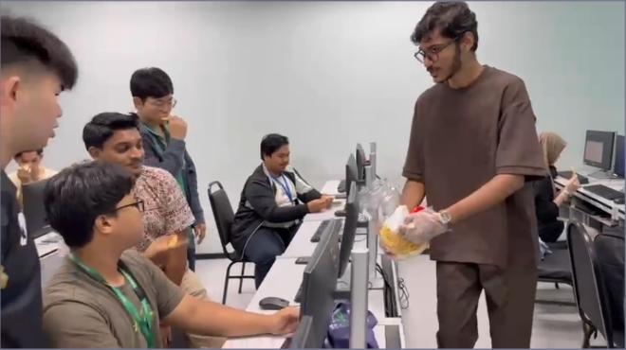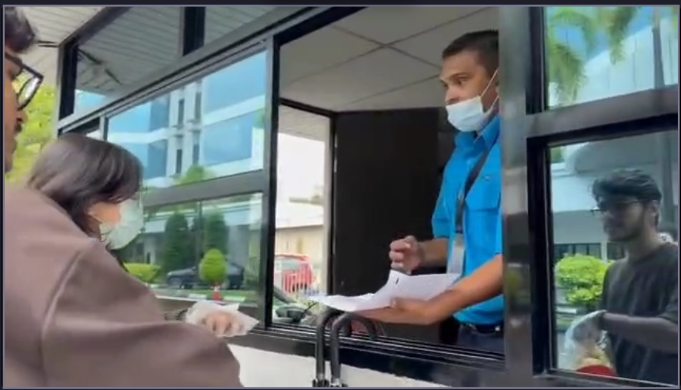

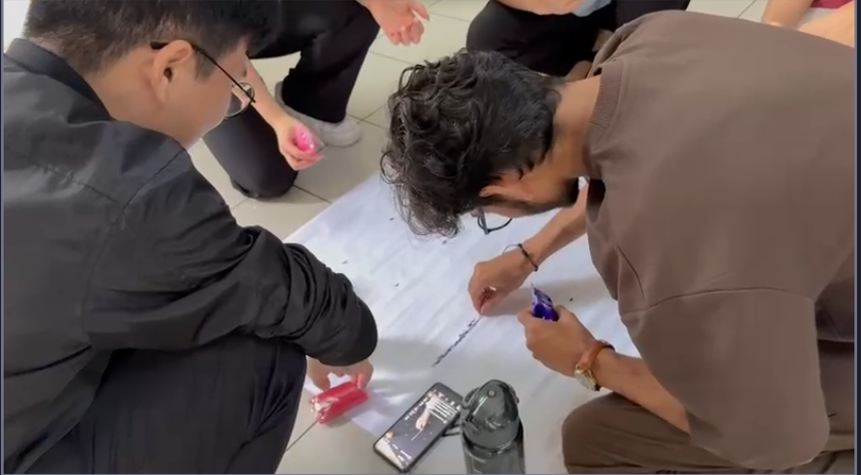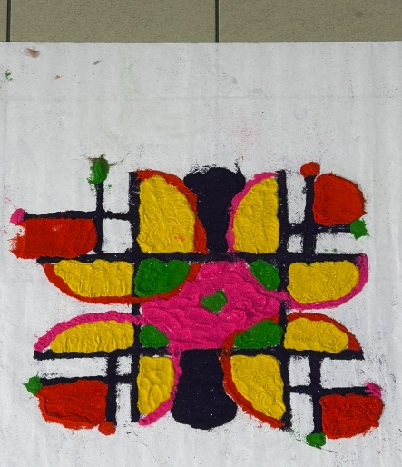

Recording Vice Secretary  Jeffrey Quah Jun Hooi | President  Won Wanqi Chloe | Advisor  Dr. Koh Chong Lin

